MOBI3002: A3 – Bouncing

Assignment Submission

By: Connor Goodwin

W#: W0488245

Date: 2025-09-22

1. **[10%]** Change the box color...  i.e. the background colour. What did you do?

I went to the BoucingBallView class and changed the object instantiation’s constructor paremetor from BLACK to RED.

Class: BouncingBallView

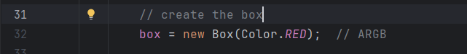

1. **[10%]**Change the color of newly made ball to a new random color for each new ball. What did you do?

I generated 3 random numbers, one for red, one for green, and one for blue. I used the Color.rgb method, and passed in the generated colors for the red green and blue arguments for the rgb method.

Class: BouncingBallView

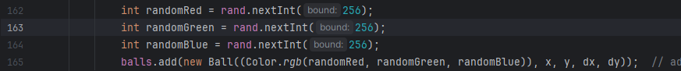

1. **[10%]**Make the newly made balls go super-fast and super-slow (with a code change).  What did you do?

I made a variable called: “fastOrSlow”, that will generate either a 1 or 2. If 1 is generated then the ball will be fast, otherwise the ball will be slow.

1. **[10%]**Try different approaches for invalidate() (different code locations, methods, ...):

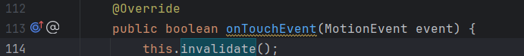



* 1. Does the program still work each time?

Each time it doesn’t seem to change anything.

* 1. What does invalidate() do?  What happens when it isn't called at all?

When it is not called within the ondraw method: 

It seems to freeze all the balls until another ball is spawned. Invalidate will say that everything on the screen should be updated the next time onDraw is called.

* 1. What are the times that onDraw() is called?

onDraw is never explicitly called by any line in the code, it is called within the android framework itself. Invalidate tells the framework that onDraw should be called again in the next frame.

1. **[10%]**Add a square shape class...fast swipes makes the square shape, slow swipes make circles.

1. **[10/10%]**Add a rectangle shape...any time a shape collides with that rectangle you increment a score count (show score on logcat).

1. **[20%]**Think of another change (...and do that change) yourself, ...What did you do? Show this in your MP4.

I added an Image Rectangle class, that is just a rectangle but with an image on it.

